TỔNG LIÊN ĐOÀN LAO ĐỘNG VIỆT NAM

**TRƯỜNG ĐẠI HỌC TÔN ĐỨC THẮNG**

**KHOA CÔNG NGHỆ THÔNG TIN**



**ĐỒ ÁN CUỐI KÌ MÔN CÔNG NGHỆ PHẦN MỀM**

**…tên đề tài…**

*Người hướng dẫn*:  **ĐẶNG MINH THẮNG**

*Người thực hiện*: **PHÙ PHƯƠNG TÍN – 518H0675**

**NGUYỄN QUANG TUẤN – 518H6082**

Lớp **: 18H50302**

Khoá  **: 22**

**THÀNH PHỐ HỒ CHÍ MINH, NĂM 2021**

TỔNG LIÊN ĐOÀN LAO ĐỘNG VIỆT NAM

**TRƯỜNG ĐẠI HỌC TÔN ĐỨC THẮNG**

**KHOA CÔNG NGHỆ THÔNG TIN**



**BÀI TẬP LỚN/ĐỒ ÁN CUỐI KÌ MÔN ………………….**

**…tên đề tài…**

Người hướng dẫn: **ĐẶNG MINH THẮNG**

Người thực hiện: **PHÙ PHƯƠNG TÍN – 518H0675**

**NGUYỄN QUANG TUẤN – 518H6082**

Lớp **: 18H50302**

Khoá  **: 22**

**THÀNH PHỐ HỒ CHÍ MINH, NĂM 2021**

**LỜI CẢM ƠN**

Lời đầu tiên chúng em xin được gửi lời cảm ơn chân thành nhất đến nhà trường và khoa Công nghệ thông tin vì đã tạo điều kiện để chúng em có thể thực hiện dự án này.

Em xin chân thành cảm ơn thầy Đặng Minh Thắng đã hỗ trợ, cho chúng em những hướng dẫn và lời khuyên cùng những kiến thức bổ ích để cho chúng em trong cả quá trình học tập và thực hiện dự án này.

**ĐỒ ÁN ĐƯỢC HOÀN THÀNH**

**TẠI TRƯỜNG ĐẠI HỌC TÔN ĐỨC THẮNG**

Tôi xin cam đoan đây là sản phẩm đồ án của riêng tôi / chúng tôi và được sự hướng dẫn của thầy Đặng Minh Thắng. Các nội dung nghiên cứu, kết quả trong đề tài này là trung thực và chưa công bố dưới bất kỳ hình thức nào trước đây. Những số liệu trong các bảng biểu phục vụ cho việc phân tích, nhận xét, đánh giá được chính tác giả thu thập từ các nguồn khác nhau có ghi rõ trong phần tài liệu tham khảo.

Ngoài ra, trong đồ án còn sử dụng một số nhận xét, đánh giá cũng như số liệu của các tác giả khác, cơ quan tổ chức khác đều có trích dẫn và chú thích nguồn gốc.

**Nếu phát hiện có bất kỳ sự gian lận nào tôi xin hoàn toàn chịu trách nhiệm về nội dung đồ án của mình.** Trường đại học Tôn Đức Thắng không liên quan đến những vi phạm tác quyền, bản quyền do tôi gây ra trong quá trình thực hiện (nếu có).

*TP. Hồ Chí Minh, ngày tháng năm*

*Tác giả*

*(ký tên và ghi rõ họ tên)*

*Phù Phương Tín*

*Nguyễn Quang Tuấn*

**TÓM TẮT**

We decided to do the project as soon as possible because we don't have much experience and knowledge about this project. We learned about system architecture and development model together and choose what we think is right for the project. We ended up choosing to do this project based on the agile model to both design and develop the user interface screens while improving the functionality and learning more about both how to solve the problems we are encountered.

**MỤC LỤC**

LỜI CẢM ƠN 1

TÓM TẮT 3

MỤC LỤC 4

Chapter 1: Introduction 7

1.1. Purpose and Scope 7

1.2. Product Overview 7

Chapter 2: Project Management Plan 8

2.1. Project Organization 8

2.2. Waterfall Model 8

2.3. Risk Analysis 10

2.4. Hardware and Software Resource Requirements 10

2.5. Deliverables and Schedule 10

Chapter 3: Requirement Specification 12

3.1. Stakeholders for the system 12

3.2 Use case model 12

3.2.1 Graphical use case model 12

3.2.2 Textual Description for each use case 13

3.3 Functional requirements  15

3.4 Non-Functional requirements  15

Chapter 4: Design 16

4.1 Architecture 16

4.2 Database design 16

4.3 class diagrams 16

4.4. sequence diagrams 16

4.4.1. Register 16

4.4.2. Login 17

4.4.3. Retailer order 17

4.4.4. Retailer view order history 18

4.4.5. Create a import form 18

4.4.6. Create a export form 19

4.4.7. View import/export history 19

4.4.8. View and change order status 20

Chapter 5: Demo 21

5.1. Link source code (git): 21

5.2. Link video demo: 21

5.3. Design interface 21

5.3.1. login page 21

5.3.2. register page 21

5.3.3. retailer order page 22

5.3.4. Retailer order history page 23

5.3.5. Accountant import/export page 24

5.3.6. Accountant manage order page 25

5.3.7. import/export history page 25

TÀI LIỆU THAM KHẢO 28

**Chapter 1: Introduction**

**1.1. Purpose and Scope**

Purpose:

To control and list items in/out/inventory easier and more accurately.

Make purchases and payments faster and easier.

Scope: This software is used in warehouse goods

**1.2. Product Overview**

|  |  |
| --- | --- |
| Function | Usage circumstances |
| Create a warehouse receipt (1 warehouse receipt will include many items) | When the company imports goods have arrived |
| Allow the dealer to order a list of items and choose Payment method (Cash, bank transfer, Momo...) | When buying, selling |
| Create warehouse release slip to deliver goods to customers agent (print the delivery note), update the status of the order as being shipped and Update agent payment status. | When the goods are released from the warehouse |
| Can review the statistics of goods in and out, monthly revenue. | When making statistics and checking |
| Create accounts for each object | For login to use system function |

**Chapter 2: Project Management Plan**

**2.1. Project Organization**

The project will be divided into to 8 step:

* Do the documentation. List the functions, user case, basic requirements
* Re-validate the system's functions and requirements
* Create class diagrams, database, sequence diagram.
* Determine the language and technology to implement the project (the advantages that this language/technology brings compared to other languages/technology)
* Project codeing
* Testing
* Project implement
* Maintance

**2.2. Waterfall Model**

In this project we use waterfall model

**Model analysis:**

* Requirement gathering: Requirements gathering and analysis A company selling functional facts to agents needs software in during this phase.
* System Analysis: Analyze and design software systems, determine the overall system architecture of the software.
* Coding: The system is developed by unit and integrated in the next phase. Each Unit developed and tested by the dev is called a Unit Test.
* Testing: Install and test the software. The main job of this phase is to check and correct all the errors found so that the software works correctly and according to the requirements specification document.
* Implementation: Deploy the system in a customer environment and bring it to market.
* Operations and Maintenance: Maintain the system when there are any changes from customers and users.

All these phases are cascaded to each other in which progress is seen as flowing steadily downwards (like a waterfall) through the phases. The next phase is started only after the defined set of goals are achieved for previous phase and it is signed off. And in this model, phases do not overlap.

We chose Waterfall model because:

* Requirements are very well documented, clear and fixed
* Product definition is stable.
* The project is short.

**Advantages of the Waterfall Model are as follows :**

* Simple and easy to understand, easy to use and easy to manage.
* Works well for smaller projects where requirements are very well understood.
* Clearly defined stages.
* Easy to arrange tasks.
* Process and results are well documented.
* Validation at each stage, ensuring early detection of defects

**Disadvantages of the Waterfall Model are as follows :**

* Less flexibility, limited adjustment range.
* It is difficult to measure development in each stage.
* The model is not suitable for changes in requirements during the development life cycle.
* Difficult to return once a certain period has ended

**2.3. Risk Analysis**

* No products are produced until the end of the life cycle.
* High risk and uncertainty if there is a change in requirements.
* It is difficult to measure progress in stages.
* Cannot reply to the change request.

**2.4. Hardware and Software Resource Requirements**

(Do not forget to describe what new software or hardware each team member learned during the project)

**2.5. Deliverables and Schedule**

Deliverables : Before 16/01/2022, we must finish all the project (Document must done, software is able to used).

Schedule:

* November 29th 2021, determine the model for project, list the functions, user case, basic requirements
* December 5th, re-validate the system's functions and requirements and complete the work done in the report
* December 7th create repository on git, class diagrams, database, sequence diagram and complete the work done in the report
* December 9th, determine the architecture, language and technology to implement the project
* December 11th 2021 to January 4th 2022 , coding user interface and system function
* January 8th, create test case and testing
* January 8th to 15th, fixing bug, improved interface and functionality
* January 15th to 16th, finalize products and reports

**Chapter 3: Requirement Specification**

**3.1. Stakeholders for the system**

Primary stakeholders:

* Customer ( Pharmacy company )
* Business Analyst

Project team:

* Project manager
* UI/UX Designer
* Developers

Secondary stakeholders:

* End users
* Competitors
* Government

**3.2 Use case model**

|  |  |
| --- | --- |
| **Actors** | **Description** |
| Accountant  (Kế toán) | Keep the numbers of products in the warehouse updated.  Inform the retailers on their deliveries and request them to complete their payments if needed.  Have the ability to see warehouse statistics and the company’s monthly income. |
| Retailers (Đại lý) | A retailer can create a request to purchase products. |

**3.2.1 Graphical use case model**

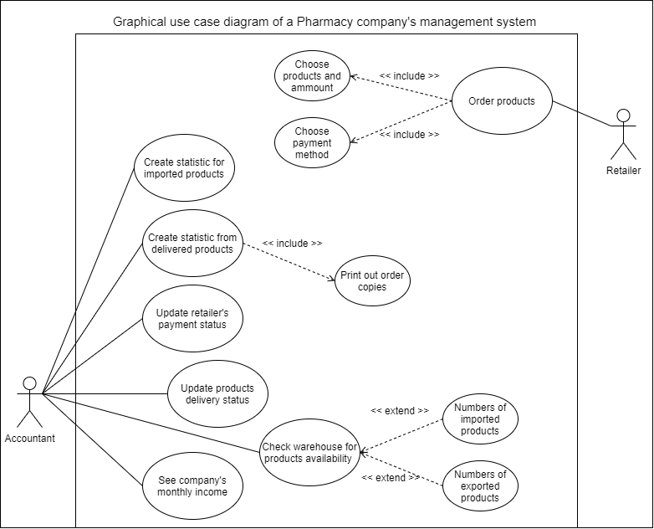  
  
  
**3.2.2 Textual Description for each use case**

**Use case #1:**

|  |  |  |
| --- | --- | --- |
| **Use case** | A retailer wants to purchase some products from the pharmacy company’s website. | |
| **Actor** | Retailer | |
| **Goal** | To create an order to purchase some products. | |
| **Overview** | A retailer has a shortage of products, they request an order for some products from the pharmacy company’s website. | |
| **Typical course of events** | Actor action  1. Login to their account.  4. Starts adding products and amounts to cart  5. Proceeds to the checkout section  7. Fills in information and address  8. Add payment method | System response  2. Check for login authentication  3. Redirect to the ordering page    6. Redirect to the checkout page    9. Order information is stored into the database. |
| **Alternative courses**  **Step 1** | The user doesn’t  have an account and is required to create one to be able to purchase products. | |

**Use case #2:**

|  |  |  |
| --- | --- | --- |
| **Use case** | A retailer wants to purchase some products from the pharmacy company’s website.  The accountant creates a delivery order to send the products to the retailer. | |
| **Actor** | Accountant | |
| **Goal** | To create a delivery order to the retailer and update the warehouse’s products’ number. | |
| **Overview** | The system informs the accountant that there is an order from a retailer. The accountant will then create a file to be able to take and update products’ quantity in the warehouse that will be delivered to the retailer. | |
| **Typical course of events** | Actor action  1. Login to their account.  4. Reads the retailer product’s order  5. Create a request to export the products from the warehouse  7. Create a delivery to the retailer  8. Print a copy of the order | System response  2. Check for login authentication  3. Redirect to the orders managing page    6. System checks database for products availability |

**3.3 Functional requirements**

* A retailer can create an order to buy multiple products.
* An accountant shall be able to see incoming orders, the warehouse’s product quantity and the company monthly incomes.
* An accountant can create a request to take out or import new products into the warehouse.
* An accountant can update delivery status and the retailer payments.

**3.4 Non-Functional requirements**

* The retailer can either choose their payment method during ordering or choose later when the products are being delivered.

**Chapter 4: Design**

**4.1 Architecture**

**4.2 Database design**

The database type that this project uses is NoSQL type, since NoSQL is developer friendly and it is much easier to make updates.

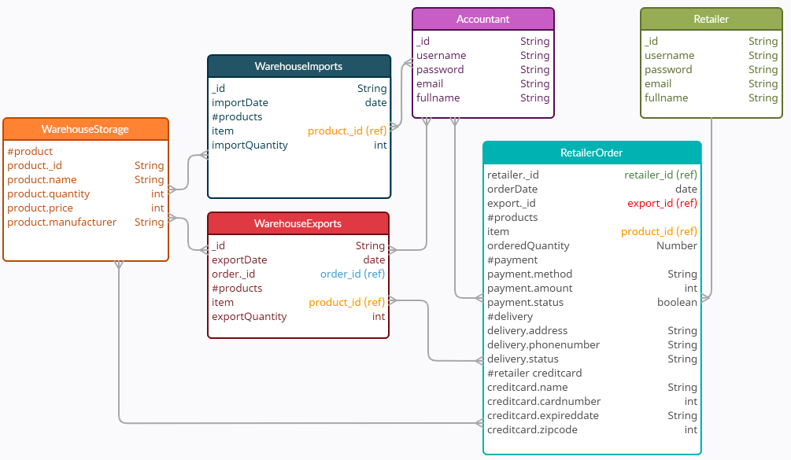

**4.3 class diagrams**

**4.4. sequence diagrams**

**4.4.1. Register**

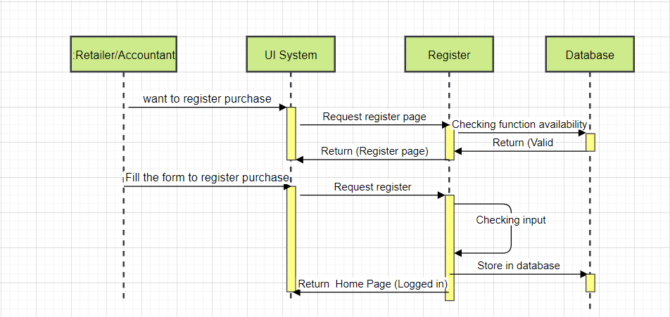

**4.4.2. Login**

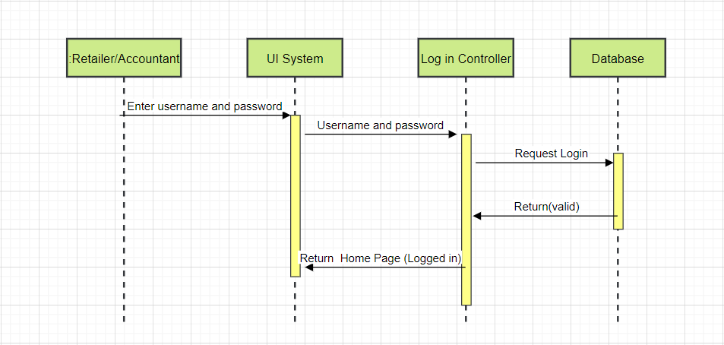

**4.4.3. Retailer order**

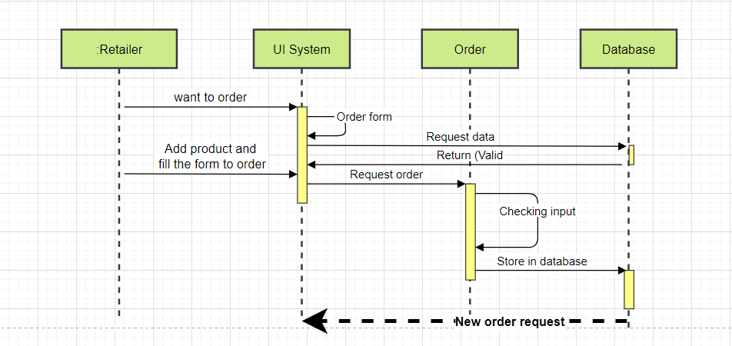

**4.4.4. Retailer view order history**

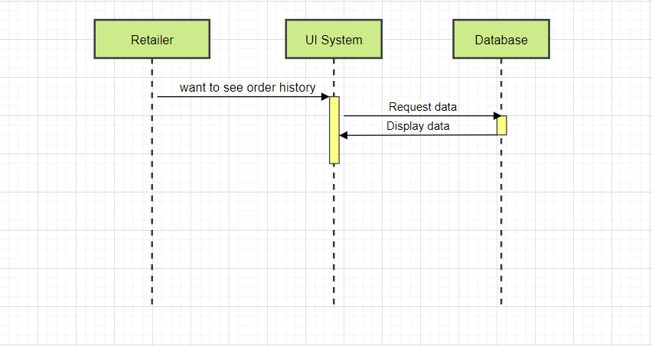

**4.4.5. Create a import form**

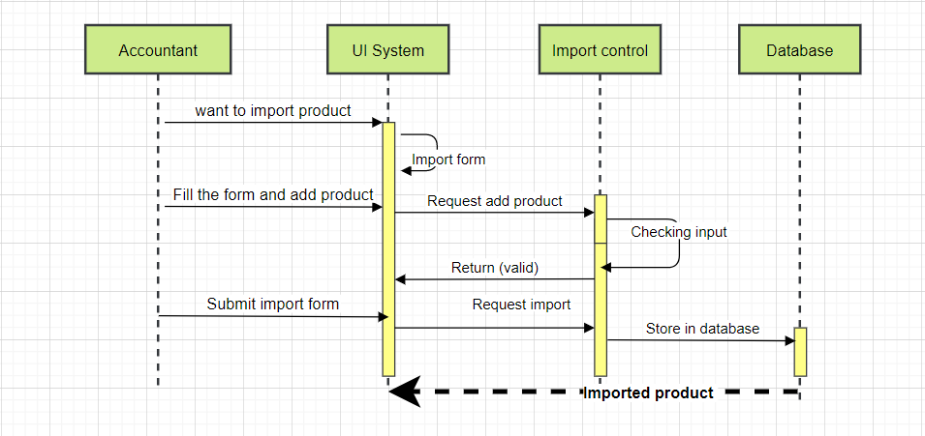

**4.4.6. Create a export form**

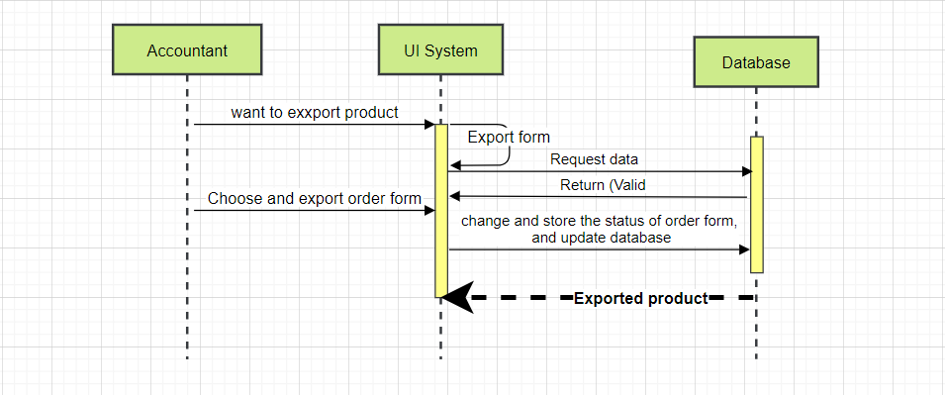

**4.4.7. View import/export history**

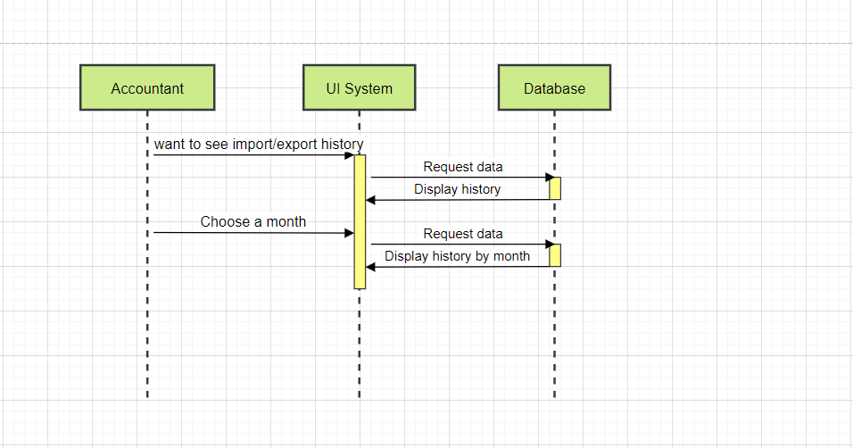

**4.4.8. View and change order status**

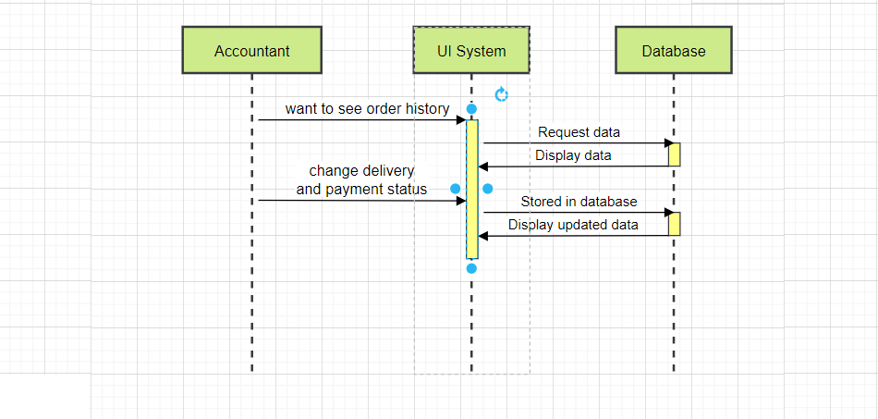

**Chapter 5: Demo**

**5.1. Link source code (git):**

**<https://github.com/Yosutta/CKCNPM>**

**5.2. Link video demo:**

**5.3. Design interface**

**5.3.1. login page**

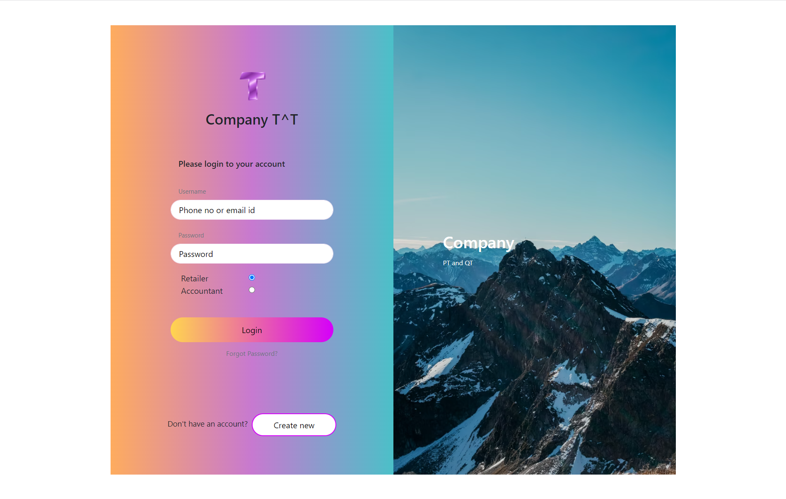

**5.3.2. register page**

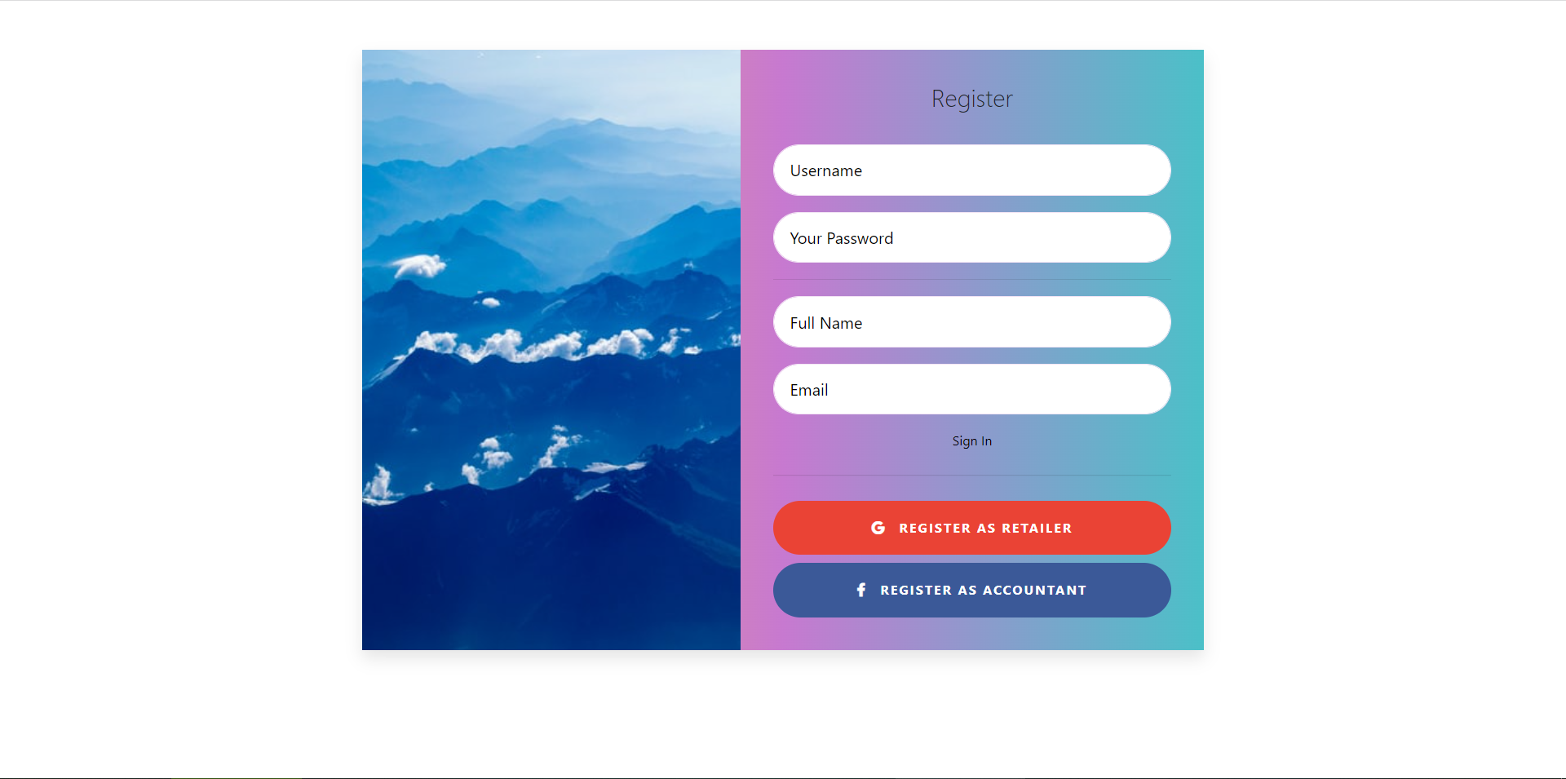

**5.3.3. retailer order page**

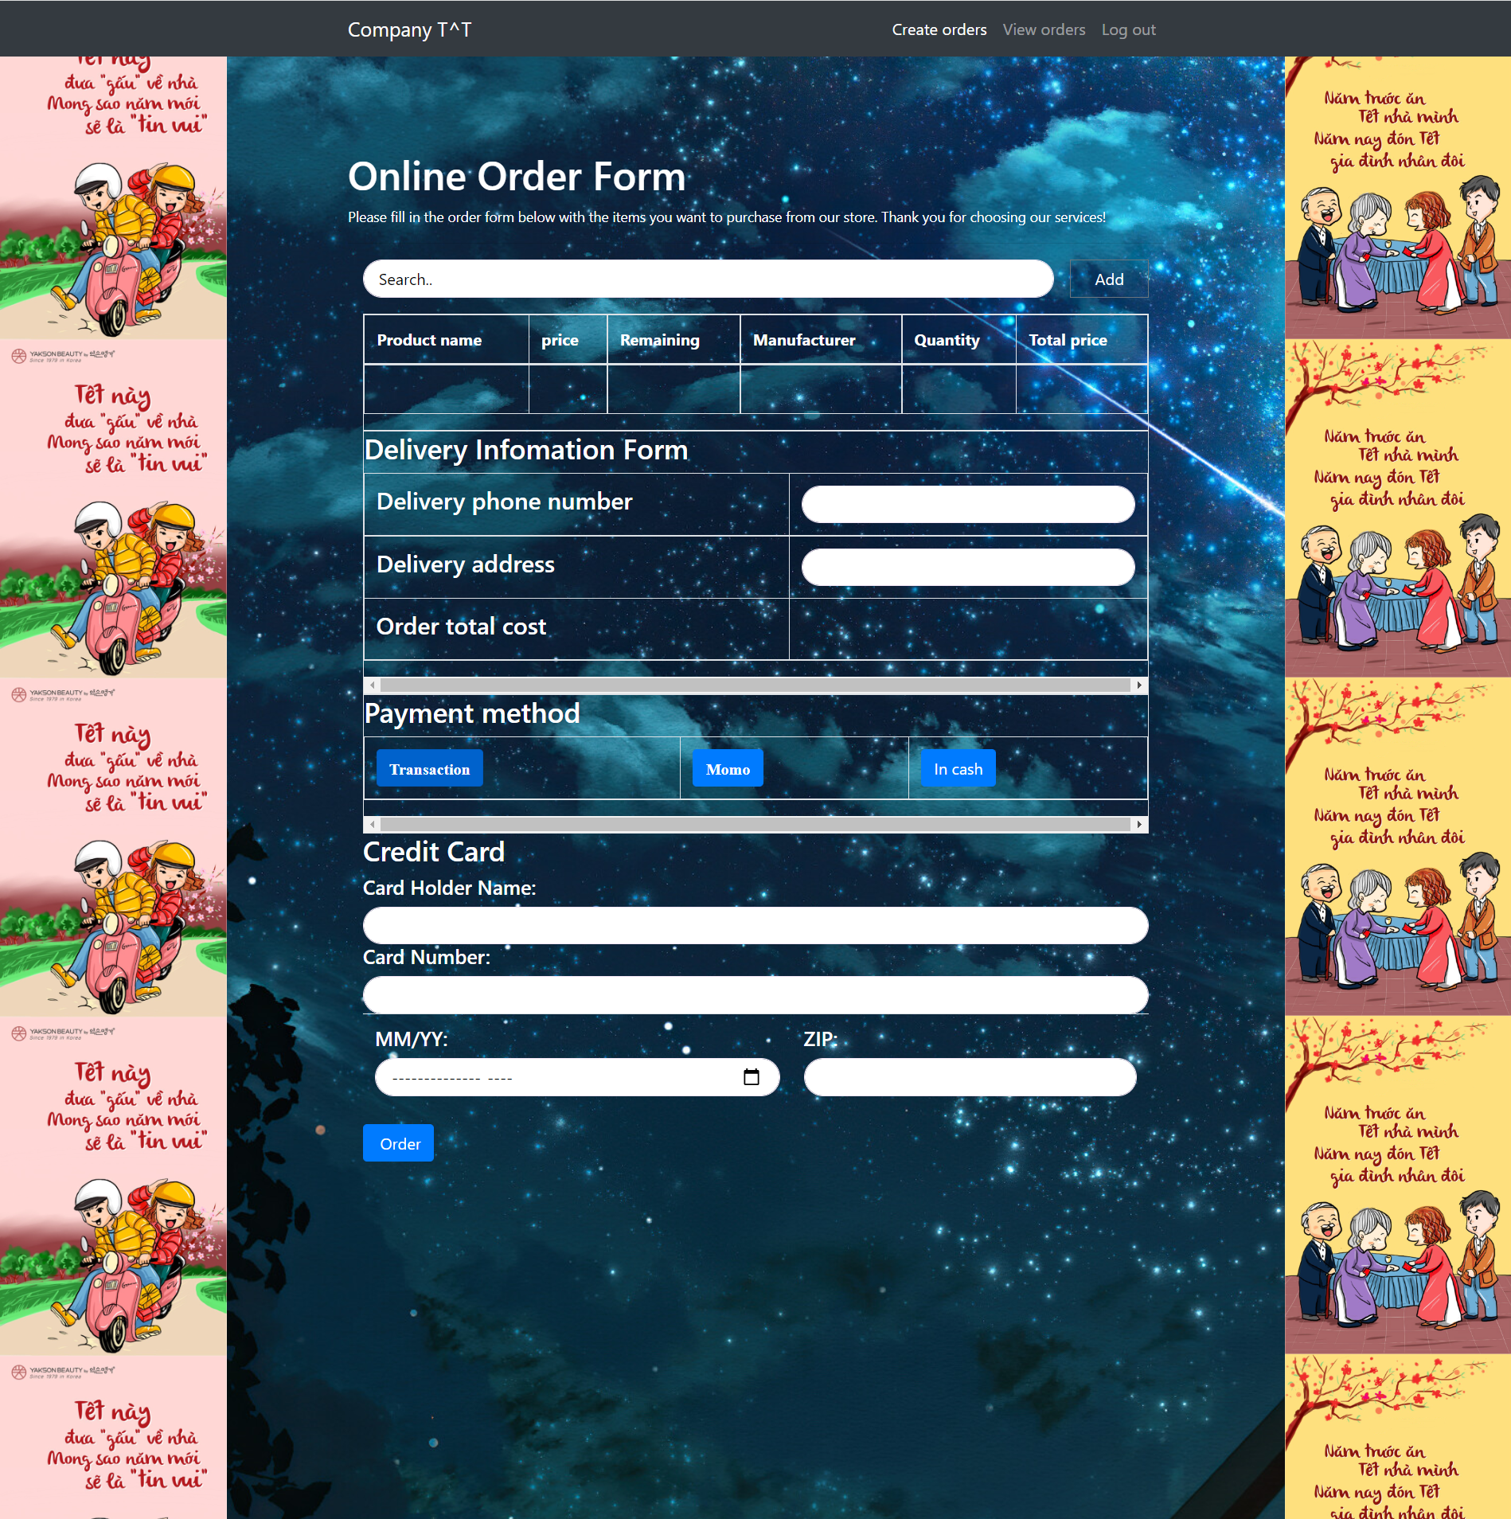

**5.3.4. Retailer order history page**

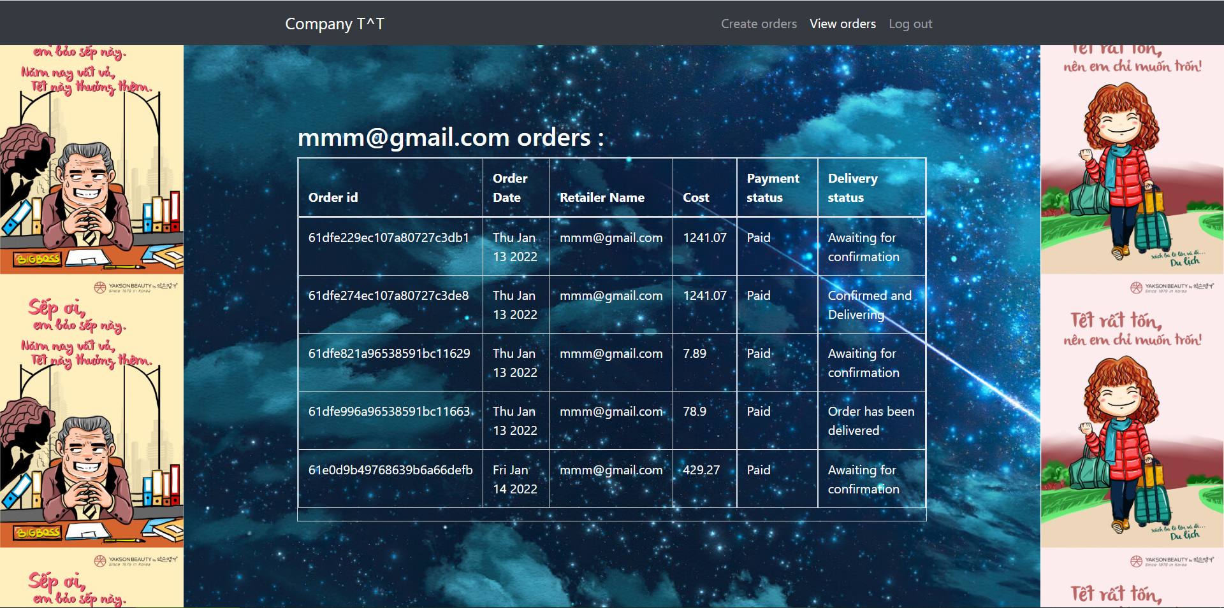

**5.3.5. Accountant import/export page**

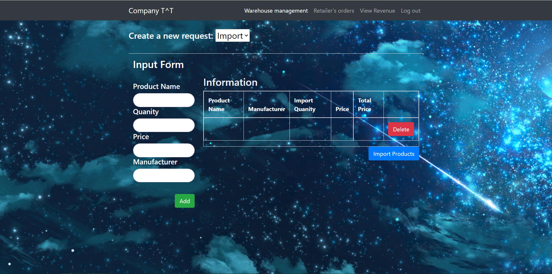

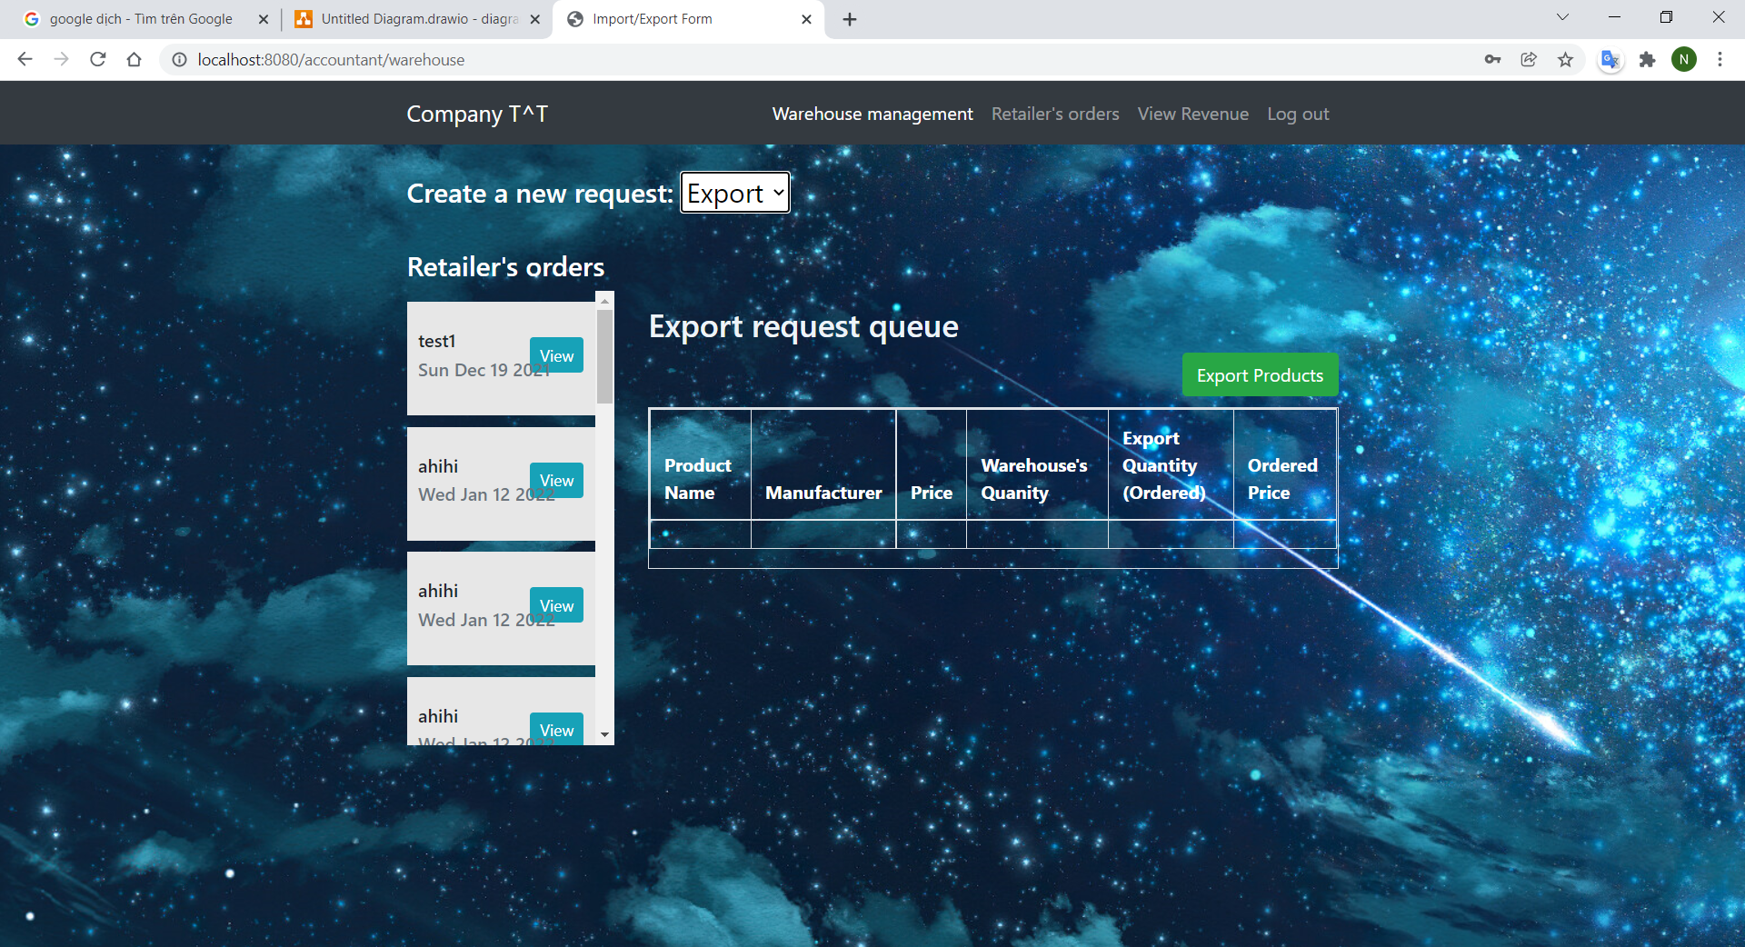

**5.3.6. Accountant manage order page**

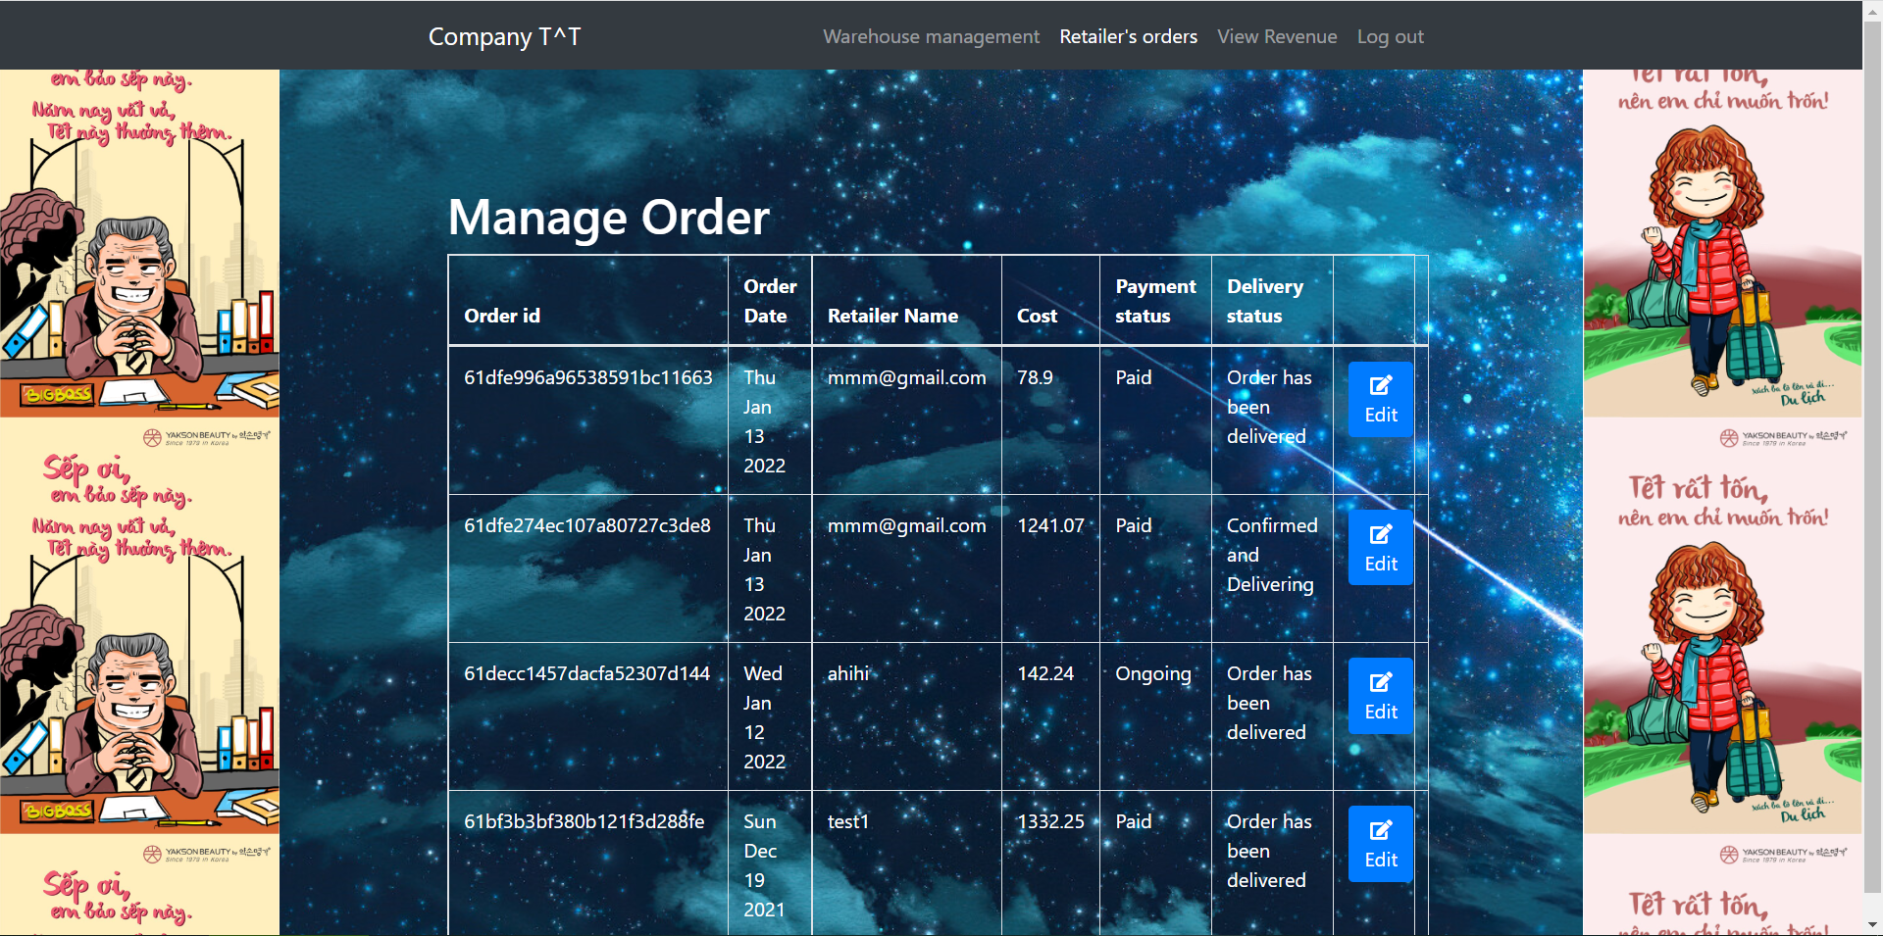

**5.3.7. import/export history page**

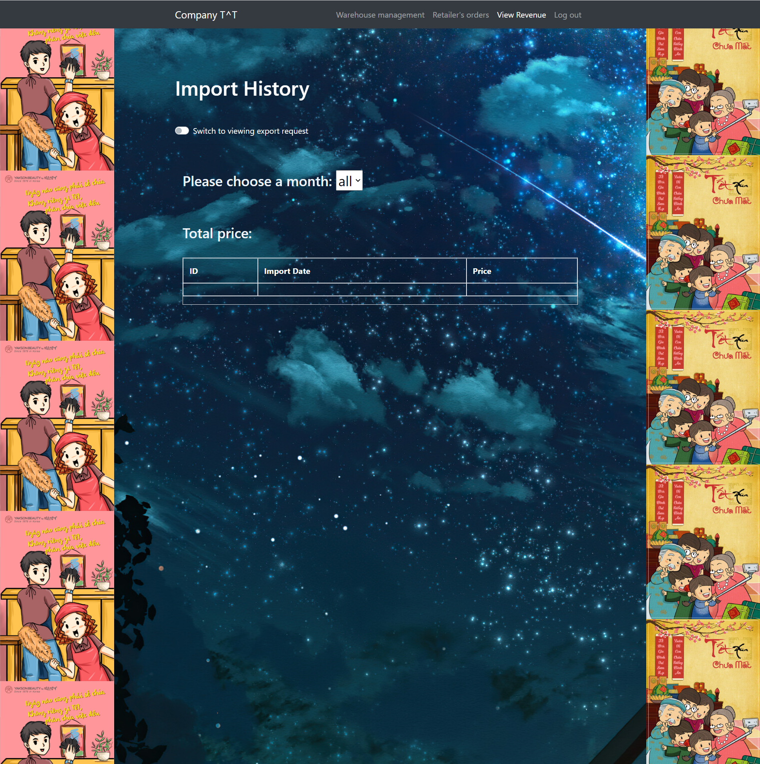

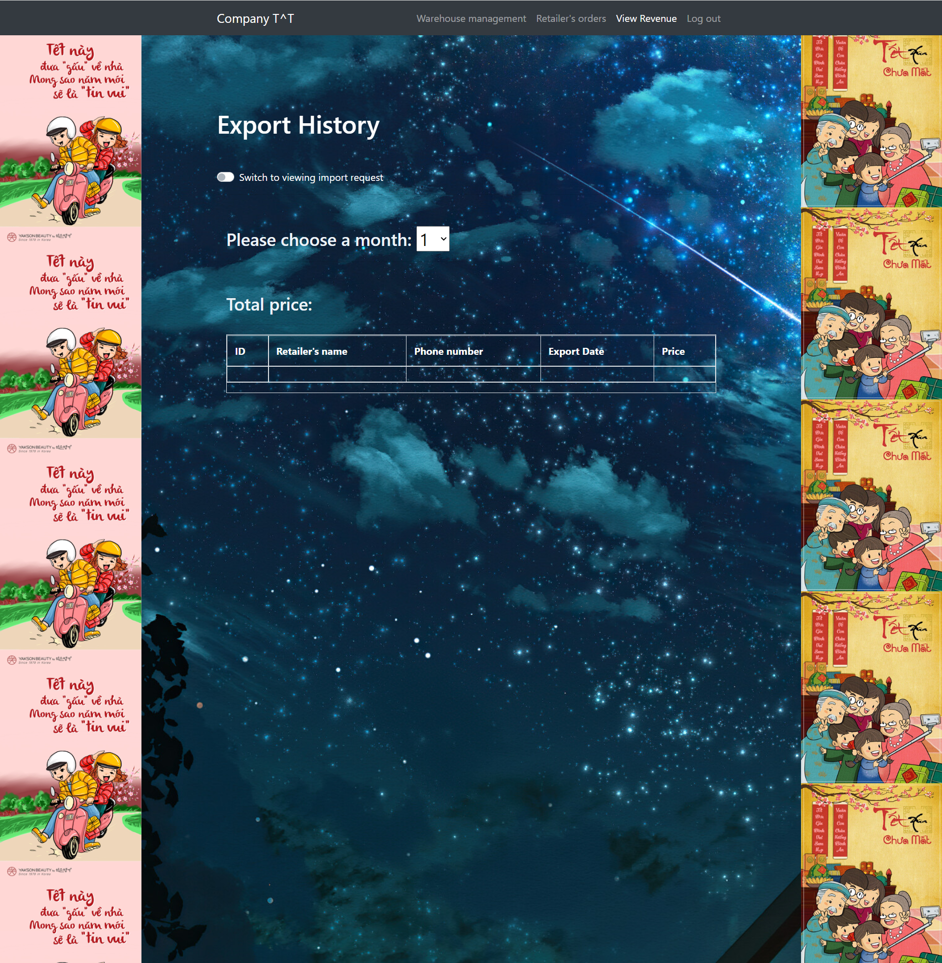

**TÀI LIỆU THAM KHẢO**